A1336 AM,S-Peru-Chancay-Doll-Embroidered Face-Triplet-1940 AD/CE

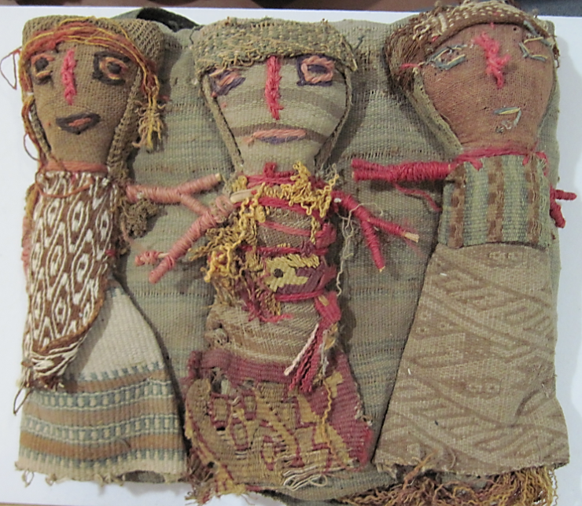

**Case no.:**

**Accession Number: 1336**

**Formal Label:** Peru-Chancay-Doll-Embroidered Face-Triplet-1940 AD/CE

**Display Description:**

The Chancay culture developed 1000-1470 AD/CE on the central coastal valleys of Peru of the Fortaleza, Pativilca, Supe, Huaura, Chancay, [Chillón](https://en.wikipedia.org/wiki/Chill%C3%B3n_River" \o "Chillón River), [Rimac](https://en.wikipedia.org/wiki/R%C3%ADmac_River" \o "Rímac River) and [Lurin](https://en.wikipedia.org/wiki/Lur%C3%ADn_River" \o "Lurín River) Rivers following the demise of the Wari empire.

These beautiful dolls, dressed in exquisite textiles, blur the lines between past and present. These dolls were sewn sometime in the 1940s with fragments of cloth dating to 1000-1470 AD/CE.

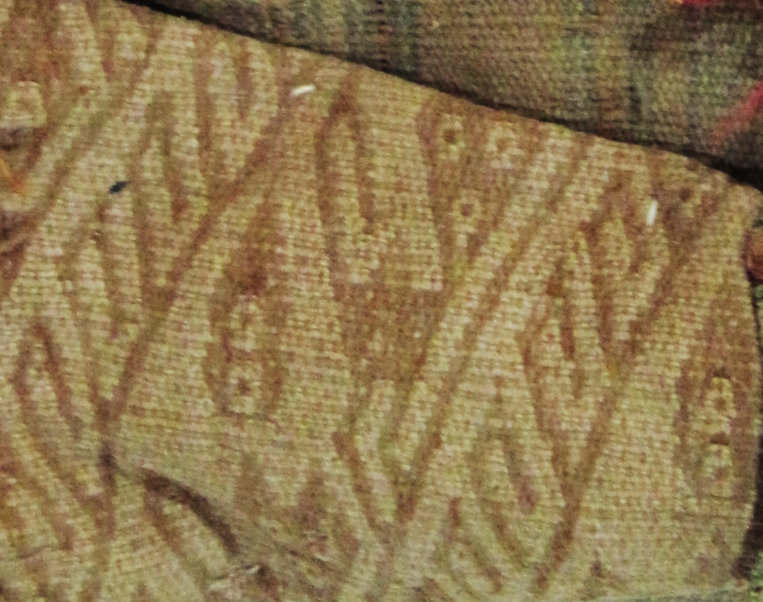

Fig. Chancay feline ochre image on buff textile.

In the Chancay culture, these dolls were placed in graves, and it is believed that they were meant as companions for the departing soul, like guardian angels. They are always women, often in groups of three like this grouping. They mostly have cheerful faces. These dolls offer us a rare chance to closely examine the exquisite threads and fabrics from one of the world's most sophisticated textile cultures.

Dolls like these are replicas of a doll-making tradition that existed in the Chancay culture and can be distinguished from original Chancay dolls that have special tapestry woven faces that are unique to each doll. The replicas, each still unique, have embroidered faces like these.

**LC Classification:** F 3429.1 .C47

**Date or Time Horizon:** 1940

**Geographical Area:** Lima

**Map, GPS coordinates: 11º34'6.61" S 77º14'13.9" W**

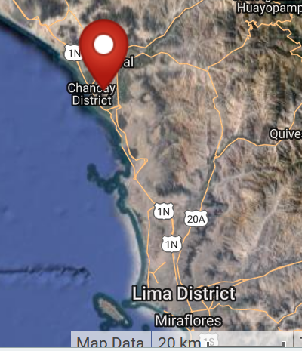

**Cultural Affiliation:** Chancay

**Media:** wool. dyes

**Dimensions:** W1196.32 mm, 7.73 in; H 166.92 mm, 6.57 in

**Weight: 181 gm, 6 5/8 oz**

**Condition: made from textiles dating to ca. 1100-1400 AD/CE about 1940**

**Provenance:** unknown

**Discussion:**

Textile production was enormous in the dry air of the central coast of Peru, which is considered one of the driest places on earth. Lack of bacteria, and arid soil have combined to preserve the fabrics amazingly well.

**References:**

Hodnett, M. K. 1999. *Pre-Columbian dolls in the Amano Museum = Muñecos precolombinos en el Museo Amano*. Lima, Perú: Museo Amano.

Lehman, Hattie Jo. 2005. “Textiles of the Chimú and Chancay cultures of coastal Peru woven during the Late Intermediate Period: a comparison of processes and techniques.” M.A. University of Montana.